Visit to Automation Expo
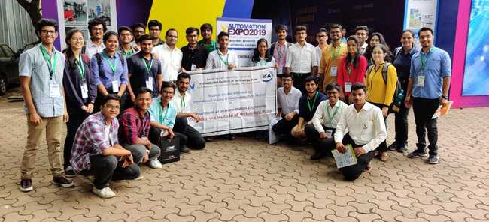
On 29th September 2019 , ISA VIT Pune arranged a visit to Automation expo 2019 at the Bombay Exhibition and Convention centre, Mumbai. Around 30 students from Instrumentation department along with Kapil Mundada sir were present for the visit. We started from Pune at around 6:30 am by bus and reached the destination before noon. Even though it was a tiresome journey under scorching heat of sun, the students were as enthusiastic as they were in the morning.
After passing through the security check, the students had entered , as one may call- ‘The world of automation!’. Huge machines, robots, attractive posters and holograms , people from all over the world were present at this grand expo. Various companies like Mitsubishi, Yamaha, TATA, Yokogawa and many more startup companies had their products and technologies presented at the expo. Many students had a great interaction with these automation professionals who were keen about sharing their knowledge with one another. Force sensor systems, Pressure measurement systems, robotic arms , IoT based projects, image processing projects, level measurement systems , machine learning! So many domains and mind blowing ideas left all the students amazed.
Overall , it was a fantastic learning experience. Definitely, many students were motivated to work in such automation companies in future.

“Automation and technology, like art are the soaring exercises of the human imagination.”

