C WORKSHOP
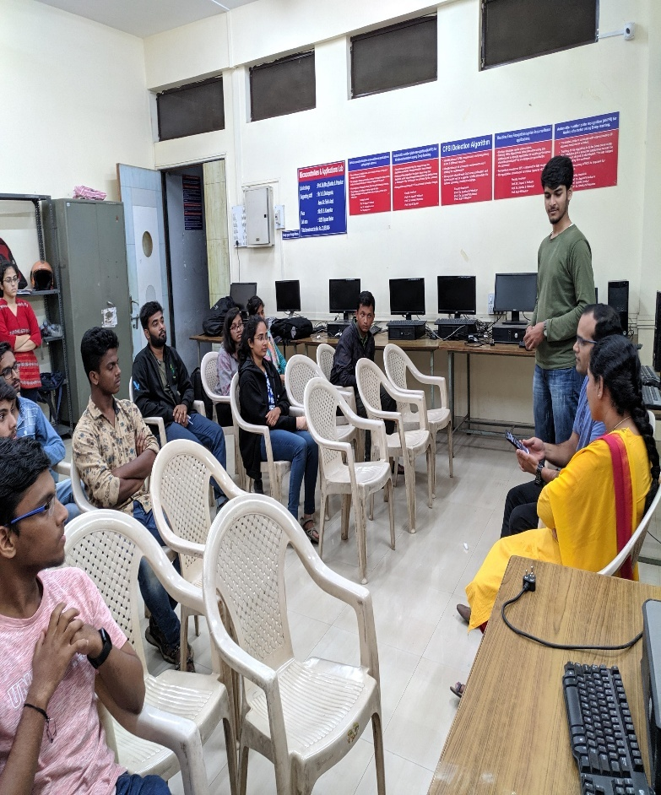
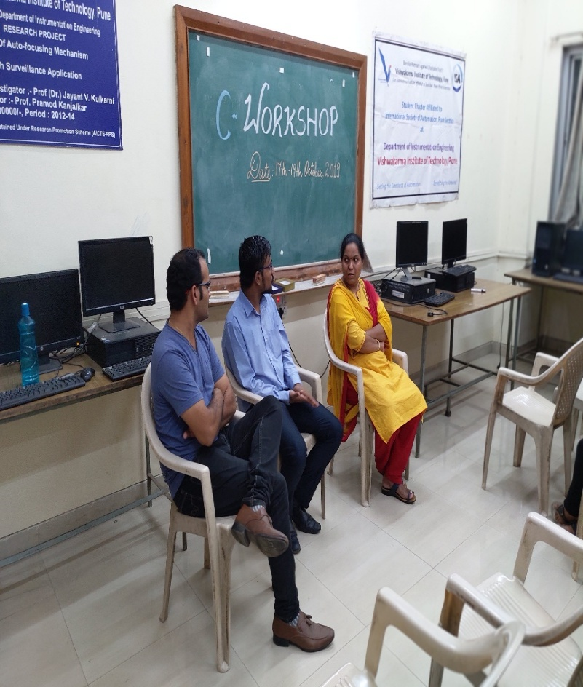
ISA VIT Pune arranged a C workshop on 17th, 18th and 19th of October for the students. C is considered as a beginner’s language. Learning every other language becomes a lot easier when you have a good command over C. Keeping this in mind, this workshop mainly targeted first year and direct second year engineering students.

The students were taught every basic concept of C from various data types to arrays and structures by one of the ISA members –Shreyas Waikar. On receiving the feedback of the participants after attending the workshop for three days, we found the level of Knowledge regarding C was certainly increased, along with it the logic building capability of each participant was improved. The fear for Coding in C language is undoubtedly minimized.
Other ISA team members helped the students to solve their doubts and errors. Overall, it was a great learning experience for the students and felt confident about coding.
To grace this occasion, Mr. Suyash Inamdar, CTO, Unithing Technologies and a pound alumni of Vishwakarma Institute of Technology had been invited on the concluding day of the workshop. Unithing Technologies is the first startup incubated in the Instrumentation and Control department of VIT Pune in 2017. He guided everyone on how to build their own start up and proceed with it, be focused on what we desire. He also shared his experience in his field. With his golden words of advice, the workshop concluded leaving the students motivated and inspired.
